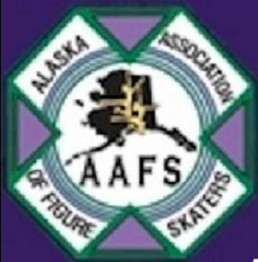 ALASKA ASSOCIATION OF FIGURE SKATERS
MAIL TO – AAFS, ATTN: MEMBERSHIP
P.O. BOX 243391, ANCHORAGE, AK 99524-3391
TELEPHONE (907) 830-7035
June 2018 – May 2019 MEMBERSHIP APPLICATION
☐ New ☐ Full Family $160 ☐ Patron $85 ☐ AAFS Professional $75 ☐ Associate $75
☐ Renewal ☐ Individual $125 ☐ Adult Skater $110 ☐ Supporting Business $105 ☐ Collegiate $170
☐ Introductory Full Family $90 ☐ Introductory Individual $65

Please see membership descriptions below.

Last Name First Name Date of Birth Age Gender US Citizen?

Adult/Parents______________________________________________________________________________________________________________________________________________

Mailing Address________________________________________________________________________ City_____________________________State__________Zip______________

Physical
Address_________________________________________________________________________________ City_____________________________State__________Zip_______________

Phone: Work_________________________ Home____________________________ Email__________________________________________________Cell______________________

I understand and agree to abide by the bylaws and rules set forth by the Alaska Association of Figure Skaters, Inc. as an adult or parent of minor above. I understand skating is a risk sport and hold harmless the Association, its agents and instructors from any liability for injuries, theft or other loss that may occur in my/our participation in AAFS activities. I authorize AAFS to print our names, addresses/telephone numbers in the Association directory. Image Release – By signing below I give and release for any and all images I provide, or provided by others, of myself or my child, to AAFS for use and publication. I will not receive any payment or compensation of any kind for the use of the images. I release AAFS of any and all liability to me for the usage of these images. I give permission for the images to be posted on bulletin boards, posted on the AAFS web site, published in event programs and posters, and in the Alaska Dispatch News. Images and/or filmed footage may also be used for advertising, publicity, or coverage of events.
Signature of applicant (over the age of 18) or guardian Date

1. _________________________________________________________________ 2. _______________________________________________________________________
Signature of two sponsoring full club members (for new members or renewals after July)
Membership Descriptions
Full Family | Up to two adults and any number of skaters (no age restriction) from the same nuclear family (includes USFS membership)
Individual | One adult and one skater (no age restriction) from the same nuclear family (includes USFS membership)
Adult Skater | One skater 18 years of age or older (includes USFS membership)
AAFS Professional | AAFS Coach (includes USFS membership)
Collegiate | A four-year membership for full-time college students (includes USFS membership)
Supporting Business | Benefactors/Supporters of events (non voting)
Associate | Up to two adults and any number of skaters from the same nuclear family who are members of another USFS club (non-voting, does not include USFS membership)
Patron | Any supporter of AAFS (non-voting, includes USFS membership)
Any members 18 years or older in the top five categories listed above are voting members.
Members in “Good Standing” are determined by the bylaws of AAFS and US Figure Skating.
The Alaska Association of Figure Skaters does not discriminate and admits skaters and members of any race, color and national or ethnic origin.
Office use only: Annual meeting discount -$5.00 ☐ ½ year discount 50% off ☐ Introductory Membership ☐
Cash ☐ $__________________ Check ☐ #__________________ $__________________ Credit Card ☐ $___________________________
initials ☐ _________date ☐_______________

